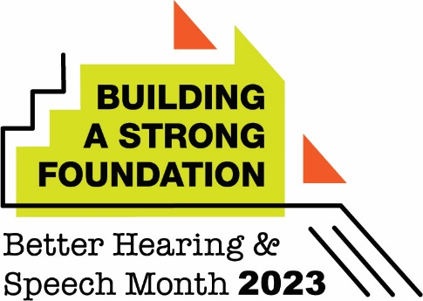

Hearing Loss Common in Children, But Families Often Don’t Know the
Early Signs

(City) Audiologist Urges Families With Hearing Concerns to Seek Help Early

(City, State – May X, 2023) As the nation recognizes Better Hearing and Speech Month this May, (city)-based audiologist (full name, credentials) encourages families to learn the signs of hearing loss and have their child’s hearing evaluated if they have concerns.

About 2–3 of every 1,000 children in the United States are born with a detectable level of hearing loss in one or both ears. Among school aged-children (6–19 years of age), almost 15% have some degree of hearing loss.

According to new data from the American Speech-Language-Hearing Association (ASHA), lack of awareness about the warning signs of communication disorders—including hearing loss—is the leading factor that keeps families from taking action.

“It’s so important for families to be able to recognize the signs of hearing loss,” said (last name).
“Fortunately, most babies in the United States are now screened for hearing loss as newborns. However, hearing difficulties can develop months or years after birth, making it critical that parents and caregivers are continually vigilant. Because unaddressed hearing loss can affect a child’s success academically and socially, I encourage a family with any questions about their child’s hearing to visit a certified audiologist for a comprehensive hearing evaluation.”

Hearing loss signs in children include the following:

- Does not alert to sound (birth – 3 months)
- Does not respond when you call their name (7–9 months)
- Does not follow simple directions (13–18 months)
- Shows delays in speech and language development (birth – 3 years)
- Has difficulty achieving academically, especially in reading and math
- Is socially isolated and unhappy in school

For more information, (last name) advises that families visit www.IdentifytheSigns.org. Families who would like to have their child evaluated can contact (office, clinic, or EI program information).

###

