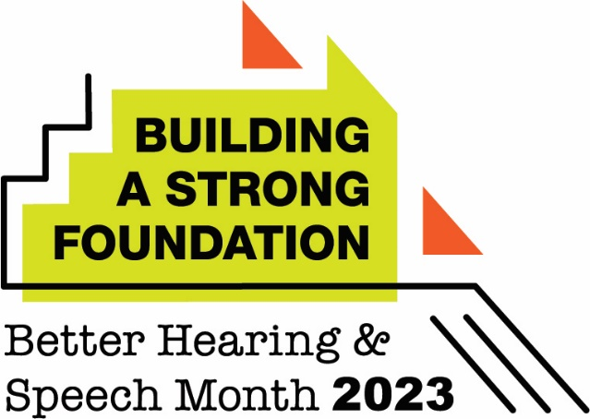

Proclamation
Communication disorders are among the most common conditions in children and adults, affecting tens of millions of people in the United States alone. Left untreated, these disorders can negatively impact a person’s academic, social, and career success—as well as their overall quality of life.
With early treatment, many communication disorders can be reversed or even prevented. However, treatment at any age or any stage can make a positive impact.
Therefore, I am pleased to join with the citizens of (your city or state) in recognizing May as Better Hearing and Speech Month. I salute the (number) audiologists and speech-language pathologists in our community who dedicate themselves every day to improving the lives of their clients, patients, and students.
Let’s also recognize the needs of those among us who have hearing, speech, language, and swallowing disorders—and do all that we can to ensure that they have access to the services of audiologists and speech-language pathologists who can help them communicate effectively and swallow safely.

