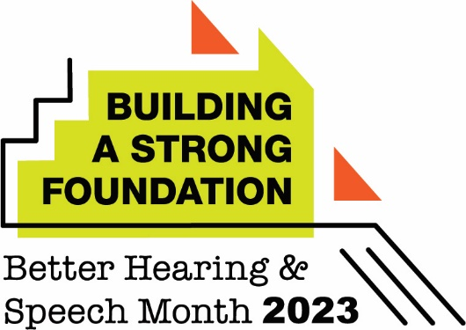

May 1, 2023

Dear Families:

My name is (first and last name, credentials), and I’m the speech-language pathologist at (school name).

I’m writing to let you know that May is Better Hearing and Speech Month. Communication disorders—which include speech, language, and hearing difficulties—are among the most common disorders that school-aged children experience. Left unaddressed, they can significantly affect a child’s academic success. You can learn more about communication disorders, and how speech-language pathologists help, here: www.asha.org/public/speech/development/speech-and-language-services-in-schools/.

It’s important for us all to reflect on how we can be respectful and supportive of those in our school community who have speech, language, or hearing difficulties. Remind children to be understanding by giving classmates time to express themselves; by focusing on what they say instead of how they say it; and by never bullying someone because of how they communicate.

It’s also a good time for families to consider how they can help their children continue to improve their communication, literacy, and learning skills during the summer months. I recommend some simple but meaningful steps: having a dedicated time for reading every day (and even writing in a summer journal); having rules for using screen-based technology (such as daily time limits or tech-free times, including family breakfasts or dinners); and prioritizing outdoor and/or creative activities. Most children won’t need workbooks or formal educational programs over the summer, but they will benefit tremendously from participating in recreational activities that allow them to move, explore, and interact with their peers.

I wish you a happy Better Hearing and Speech Month—and a fun, relaxing, and safe summer.

Best wishes,

(Insert signature)

