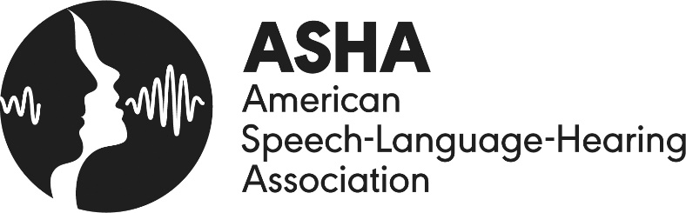

World Hearing Day (March 3) is a global observance of the World Health Organization (WHO) that is championed by the American Speech-Language-Hearing Association (ASHA).

In 2022, the theme for World Hearing Day is “To hear for life, listen with care.” Hearing loss is among the most common chronic health conditions that American adults experience. Although not all hearing loss is preventable, noise-induced hearing loss is—simply by reducing exposure to excessively loud noise. This is true for people of all ages.

Here's how you and your loved ones can avoid noise-induced hearing loss:

- For Infants and Toddlers — Parents and caregivers should pay attention to how loud toys are—especially because young children tend to hold their toys very close to their faces. Many popular products on the market exceed safe noise levels. Make them safer by taking the batteries out or putting tape over the speaker to dampen the sound. Parents should also put well-fitting earmuffs on kids when they will be in a noisy environment such as a sporting event or a fireworks display.

- For Older Children and Adolescents — Wearing earmuffs or earplugs in noisy environments remains very important, given that WHO says 40% of teens and young adults ages 12–35 are at risk for hearing loss from loud leisure activities. Children at these ages also should be taught to listen safely to their personal technology devices, especially when used with earbuds or headphones. This means keeping the volume to half and taking listening breaks every hour.

- For Adults — Certain professions—such as jobs in the airline, restaurant, or landscaping and construction industries—pose added risks to hearing, as do many everyday activities such as loud fitness classes, noisy coffee shops, and noisy hobbies. Adults should wear hearing protection in loud environments, limit exposure to noise, and see a certified audiologist if they are experiencing any symptoms of hearing damage.

Signs to pay attention to include experiencing ringing, buzzing, or pain in the ear; having difficulty following a conversation when more than one person is talking; having trouble hearing in noisy places like a restaurant or on the phone; noticing that sounds frequently seem muffled—or people often sound like they’re mumbling.

Hearing loss is far from being just a nuisance: Left untreated, it is associated with a variety of serious health conditions in adults—including cognitive decline, falls, and social isolation and depression. Hearing loss also can impact career success, mental health, and quality of life. In children, untreated hearing loss can lead to academic, social, and behavioral problems. For infants and toddlers, if hearing loss is unaddressed, it can affect their speech and language development—so it’s always important to pay attention and to get a hearing evaluation from a certified audiologist if you have concerns.

What’s a great way to observe World Hearing Day? Anyone with concerns about their hearing (or a loved one’s) should seek a hearing evaluation from a certified audiologist. Evaluations are generally covered by insurance. A searchable database of these hearing professionals can be found at www.asha.org/profind or by calling the ASHA consumer line: 800-638-8255.

###

